Glebe House School
BOARDING BOOKLET
For Staff

The school is committed to retaining boarding at Glebe House School as we believe it contributes immensely to the development of our pupils and the atmosphere of the school. This document includes statements on boarding available to pupils and/or parents and should be read by all staff involved in boarding

Aims and Ethos of the Boarding Community

- In boarding we aim to provide each child with an environment in which he / she can flourish, develop and fulfil their potential whilst staying away from home.

- The health, safety and well-being of all our children are of paramount importance to all the adults who work in the school. All children have the right to protection, regardless of age, gender, race, culture or disability, ensuring a secure and stable environment exists. They have a right to be safe in school and the school follows a specific child protection policy.

- We are committed to creating and maintaining an environment that discourages bullying and deal constructively with any instances that may occur following the whole school anti-bullying policy

- We aim to promote an open and trusting ethos ensuring each child's right to privacy, dignity, independence and individuality. Each child must be treated fairly and we aim to encourage children to learn to exercise a degree of freedom in a responsible way which develops behaviour traits of courtesy, honesty, care, co-operation and building positive relationships between each other. We follow the whole school behaviour and discipline policy, which is designed to support the way in which all members of the school live and work together.

- We cannot and should not replace the child's parents and we must take great care not to make statements to a child that are value judgements on his / her home or parental situation. Parents should feel part of the boarding process and not be excluded. We are committed to ensure that the children have the opportunity to achieve the highest standards and we all build positive relationships with parents. However, the school has procedures in place in case there are any complaints following a specific complaint policy.

- We respect the privacy of children in the bathrooms and dormitories. All staff should exercise sensitivity if pupils are in a state of undress and quietly administer their duties.

- Children, like adults, need to express their fears and emotions. The resident staff are the shoulders to cry on, the listening ears and, at times, the wall to bang the head upon. We expect and maintain high standards of politeness and awareness of others but we should be aware of the tensions in a closed community and treat the occasional outburst in this light.

GENERAL INFORMATION

Boys’ boarding: Mr Jon Turner & Mrs Charlotte Turner
jmt@glebehouseschool.co.uk 07773 774813
Girl’s boarding: Mrs Tamzine Fraulo (tjf@glebehouseschool.co.uk) 07882 497245
Headmaster: Mr Louis Taylor (louis.taylor@sglebehouseschool.co.uk) 07590 529353
School Office ghsoffice@glebehouseschool.co.uk
School Address: 2 Cromer Road, Hunstanton, Norfolk PE36 6HW
Telephone – Boy’s 01485 535473 Telephone – Girl’s 01485 532916 School office: 01485 532809 ext 1

“Living in a diverse but tightly-knit boarding community inspires children in a way that fosters their independence and gives them the confidence and skills to tackle the next vital stage of their education.” Former Chairman of IAPS

BOARDING SET UP

The girls’ boarding accommodation is situated at the top of the main school building, directly above the Headmaster’s living quarters, and is known as the ‘Eyrie’. Mrs Fraulo is responsible for girls’ boarding and spends the evenings with the girls until they are all settled in bed. At night the girls know where Mrs Farlou is, on the same corridor as them, and they can knock on her door for assistance at any time.

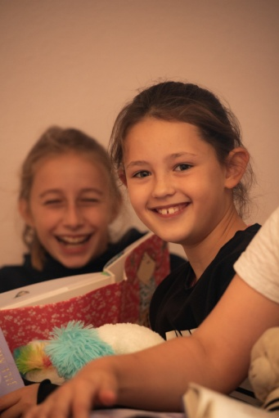
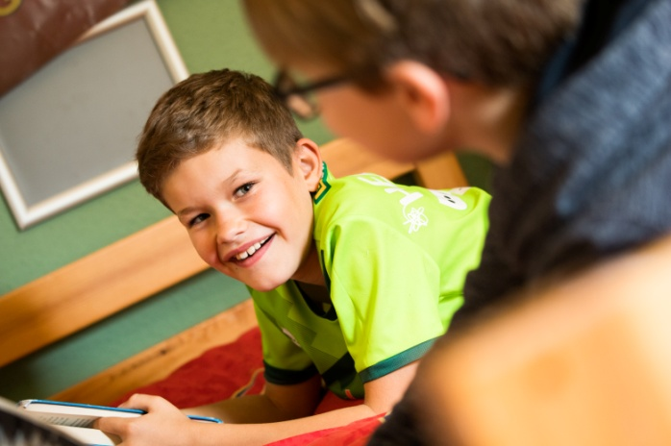

The boys’ boarding is situated in Lady Margaret Cottage which adjoins the pre-Prep building. The boys’ Housemaster, Mr Turner lives in the staff accommodation which is attached to the boarding house and is available for the children throughout the evening and night. The Headmaster is close by and can be called upon by the boys’ Housemaster in an emergency.

STAFFING

Both boarding houses are run by their respective Houseparents, although evening activities and older children’s prep time are supervised by member of the academic staff who is on duty each evening until 8pm and Gap Students help with activities as needed.
If there is an occasion when the Houseparents of either house are unable to be on duty, an experienced member of the academic staff will be asked to stand in and may stay overnight.

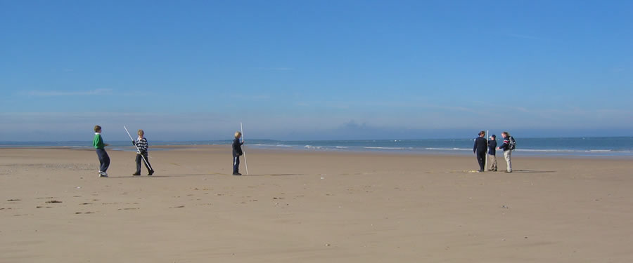

A BOARDER’S DAILY ROUTINE

7 a.m. WAKE UP TIME

The houseparent wakes up boarders and helps them to get ready for the day ahead. Boarders get washed and dressed in school uniform before meeting up and going to breakfast at 7.45a.m.

7.45a.m. BREAKFAST
Cereals, toast, tea and cooked breakfast all ready to get children going for a full day ahead. Some will be waiters on a rota basis and expected to clear the tables at the end of the meal.

8.20a.m OFF TO SCHOOL
A quick visit back to the boarding house to brush teeth, then off to registration with form tutor.

DURING THE DAY.
During the day boarders should not go back upstairs to the dormitories unless it is absolutely necessary. Even so they must get permission from Houseparents.

4.10pm LESSONS OR GAMES FINISH – ACTIVITIES BEGIN.
At 4.10pm when games or lessons finish, pupils can choose to attend one of the numerous activities available which last until 5pm.

5pm TEA
Cooked tea, followed by prep.

6-7.30pm SUPERVISED FREE-TIME
After prep finishes which will depend on age (Divisions 3-6 - 6pm; Divisions 7-8 6.30pm) boarders have free time before bed.
During this time there are set activities such as Sports Hall, ICT or Art room or boarders can use the Library, the music rooms to practise. In the summer swimming, tennis or just playing under supervision is available with the longer evenings.
If children want to do something specific then they should let one of the staff know. Boarders control through their suggestions what they do in this time within reason but staff may also run pre-arranged activities.

7.30pm
Time for Divisions III-V to go to the boarding house, Division VI-VIII at 8pm. When in the boarding house its time for a shower, change into pyjamas and dressing gown and meet up in the common room. This is freetime until bedtime where boarders can have tuck or a hot snack from the kitchen and can play games such a snooker, or just relax and watch some television. These timings are 30 mins earlier after October half term and return to normal after the May half term, return to the normal time when the evenings are lighter.

BEDTIMES
Division III-IV – 8.30pm
Division V-VI – 9 pm
Division VII-VIII – 9.15pm

Children are encouraged to read quietly in bed for 15 minutes or so before lights out. (There may be flexibility in these timings at the discretion of the Houseparents according to the combination of age groups in any one room.)

A-Z OF BOARDING

Bed-changing – Bed linen for boarders staying more than two nights a week is changed on a fixed night each week in each boarding house. Duvet covers are changed one week and bottom sheets the next. Pillow cases are changed every week.

Boarding boxes – Each boarding house has a ‘boarding box’ which is collected from the school office as the juniors go to their boarding houses. This contains the boarding register, boarders’ medical records and any relevant medication, any mail for the boarders, team sheets for the following day and any relevant messages for the Houseparents. Boarders may, as one of their duties, be asked to transport the box between the office and the boarding house, but should not be allowed to open it.

Boarding House duties – All boarders have duties to do either in the evening or in the morning in the boarding house. These are usually on a rota which is changed each term by the Houseparents. The list of duties is displayed on the notice board of each house.

Boarders’ Register – The register is filled in each evening as the boarders arrive in the boarding house. It is then kept by the Houseparents until the morning when it is returned in the Boarding Box to the School office.

Clean laundry – Clean laundry is collected from the laundry room at the end of each day and taken to the boarding houses where it is returned to its owners.

Common room – Each boarding house has a common room for the use of the pupils. These are stocked with games, jigsaw puzzles, packs of cards etc. and the pupils may also bring in their own suitable forms of entertainment. It is the pupils’ responsibility to ensure that the Common room is left clean and tidy at the end of the evening with all games put away and no litter or dirty dishes lying around.

Dirty laundry – Personal laundry is done for all full boarders. In Lady Margaret Cottage there is a basket for dirty laundry which is taken to the laundry room before breakfast each day. The girls in the Eyrie have one central basket for their dirty laundry which is also taken down daily.

Electronic equipment – MP3 players, tablets and hand-held games are all permitted in the boy’s common room but not in dormitories. They must be handed to the houseparent every evening before bedtime.

Fire doors – All fire doors in both boarding houses are shut at lights out time. Pupils are made aware of where the fire doors are and familiarised with all means of exit.

Fire Drill – Both boarding houses have a non-daytime fire practice each term which is recorded in the fire register.
First Aid – Both Houseparents have received recognised St John Ambulance first aid training and also have telephone access NHS Direct. In an emergency Paramedics will be called and/or a child transferred to hospital.

Illness – If a child becomes ill during boarding the Houseparents will care for the child appropriately giving medication only as agreed with the parents of the child. If the child is considered too ill to remain in boarding the parents will be contacted and the child sent home. Should this be considered inappropriate because of timing or distance the Houseparents will isolate the child from the other boarders and ensure the child is comfortable and supervised until such time as the parents can be contacted.

Kitchen – Each boarding house has a kitchen area for the use of the pupils under the supervision of the Houseparent. Washing up water is run by the Houseparents at the beginning of the evening and pupils are encouraged to wash their own cups and plates. The pupils are responsible for leaving the kitchen clean and tidy at the end of the evening, with bread, butter, milk etc. put away in the fridge.

Laundry – Laundry is done centrally in the school for all ‘full’ boarders and urgent items such as muddy games kit may be done for flexi boarders. Each boarding house displays a list of items to be put into the laundry by the pupils each day. The Houseparents check that this is done and also check name tapes, buttons etc.

Medical matters – Boarders’ medical records are kept in the School office during the day and sent to the relevant boarding house each night by means of the boarding boxes. The School Administrator and the Houseparents communicate any current matters of concern over boarders by means of the medical file. All medical matters, incidents and administration of medication are recorded in the medical file.

Meetings – Boarders’ meet every half term to make suggestions to the Houseparents about boarding practices and where they might be improved.

Music Practice – Boarders who have singing or instrumental lessons are encouraged to do music practice. Music practice takes place in the music rooms and staff must be aware that this is taking place.

Outdoor Play – During the summer term and the first half of the autumn term the boarders play outside during fine weather, and may be taken to the park or the beach. Bikes, skateboards, rollerblades, scooters etc. are all allowed at school on the understanding that appropriate protective clothing is worn.

Phone calls – There is a payphone in each of the boarding houses. Boarders are also allowed to bring mobile phones, which are handed into the Office in the morning, they are then taken to the Houses in the Boarding Box and put back after use. They are encouraged to speak to their parents as frequently as they wish although, if using the payphone, giving consideration to appropriate timing and to others wishing to use the phone.

Physical contact – Houseparents and staff on boarding duties should refrain from making unnecessary physical contact with pupils in the boarding situation. However, as we act in loco parentis there may be occasions when physical contact is necessary or appropriate. For the protection of all concerned this should be witnessed and parents should be informed of the circumstances.

Playclothes/Homeclothes – All boarders should have at least one set of casual clothes in school all the time. These may be worn during boarding free time.

Posters and photographs – Boarders are encouraged to bring in photographs of their family and posters to decorate their dormitories. The content of posters is monitored by the Houseparents.

Prep – Division VII and VIII boarders do 30 minutes supervised prep after supper in one of the classrooms or dining room on Monday, Tuesday and Thursday. The same rules apply during evening prep as during the school day.

Revision – During exam periods all boarders are encouraged to do extra revision during boarding time.

Shoe cleaning – School shoes are to be clean and presentable. Shoe cleaning kits are available should they need to be cleaned and polished. Slippers or socks should be worn at all times around the boarding house.

Showers / baths – All boarders take a shower or bath every evening or morning. Junior boarders (up to and including Div V) use the showers/bathrooms first, as soon as they come into the boarding house, so that they are free for the older boarders to use after. Boys use upstairs or downstairs showers as directed by the Housemaster. Shower mats are provided and are washed or hung up daily to dry.

Smoking, Alcohol, Drugs – These are totally forbidden within the school except in the case of adults consuming alcohol at school functions and even then parents should be responsible in its use. Smoking by adults is not permitted in buildings and discouraged elsewhere. Children would be severely dealt with should they partake or have substances in their possession. Our policy on such matters explains how we educate children in such matters and is available on request.

Television - A television, VCR and DVD player are provided in both boarding houses and boarders are free to watch TV during the evening. It is the responsibility of the Houseparents or member of staff on duty to ensure that any programmes are suitable viewing for the children concerned.

Tuck – Evening snacks of bread (toast), cereal, fruit and hot and cold drinks are provided in both boarding houses. Boarders are also allowed to bring a reasonable amount of tuck from home to eat in the evenings. This should be, for example, no more than one chocolate bar or packet of crisps. Items brought from home are for personal consumption only and should not be shared. Personal tuck must be kept in sealed in the storage area provided in the kitchen or common room and not in the dormitory.

Videos / DVDs – Boarders may bring in videos and/or DVDs if they wish. They must be vetted by the Houseparents and all certificate ratings strictly adhered to.

Visits – Whilst all boarders enjoy evening activity time together, boys and girls are not allowed to visit each other’s boarding houses. No male member of staff or male parent is permitted in the girls’ boarding house without the permission of the Houseparent, who must be present throughout the visit. Any visitor wishing to enter either boarding house should first seek the permission of the relevant Houseparent and be accompanied at all times.

NEW BOARDERS INDUCTION

All new boarders will be given a copy of the ‘Boarders Handbook’ that clearly lays out the routines of weekly/flexi boarding. They will also have received a letter informing them of the items they need to bring with them.

On the first day a child boards they will be taken around the boarding accommodation by the Houseparent and a senior boarder. They will be shown the following:

- the toilet and washing facilities
- The dormitories, where they will choose a free bed
- Where they keep their belongings, hang towels, dressing gowns etc
- Where they can stick pictures and posters
- The bell that calls the Houseparent in the night after lights out
- If they are a weekly boarder they will be shown the laundry rota and have this explained to them
- The duty rota will be explained

Finally, the Houseparent will sit down with the new boarder and chat through the handbook and answer any questions they might have.

CARE OF BOARDERS WHO ARE UNWELL
All parents must complete a medical form and sign an ‘In loco parentis’ form in case of emergencies and giving permission for the school to administer non-prescription drugs.

Boarder’s medical records are kept in the School office during the day and sent to the relevant boarding house each night by means of the boarding boxes. The School Administrator and the Houseparents communicate any current matters of concern over boarders by means of the medical file. All medical matters, incidents and administration of medication are recorded in the medical files.

The policy for a sick child is to try to send him/her home but if this is not possible then
a sick room with a bed is provided in both boarding houses with easy access to the toilets.

Both boarding houses have first aid cupboards easily to hand and staff have the relevant training.

In the case of medical emergencies in the girl’s boarding house and it is necessary to remove the child to a hospital, the Houseparent will take the child and the Headmaster will be in the near vicinity.

In the case of medical emergencies in the boy’s boarding house and it is necessary to remove the child to a hospital, the Houseparent will take the child and the Headmaster will be able to come over and supervise any remaining boy boarders.

PROVISION FOR PUPILS WITH PARTICULAR RELIGIOUS, DIETARY, LANGUAGE OR CULTURAL NEEDS
Glebe House is committed to equal treatment for all, regardless of an individual’s race, ethnicity, religion, sexual orientation, disability, learning difficulty, body image or social background. We believe that the educational experience can only be enriched if children are exposed to as wide a range of cultural experiences as possible whilst they are developing.

Within the boarding houses we will strive to meet any provisions that a boarder needs to follow any particular religious or cultural need.

WHAT IF A BOARDER IS UNHAPPY?

We strive to give all boarders the best support at all times at Glebe House. If the occasion arises where a child is unhappy we hope that they speak to someone at school who can help. The child can talk to a houseparent or any member of staff without fear of discrimination, humiliation and in complete confidence if they so wish. Access to parents is always open and easy to obtain, but we also have other people outside the school that children may want to contact listed below:

- The outside listeners – Reverend I E Dines 07763 211901
- Childline 0800 1111
- Independent Schools Inspectorate CAP House, 9 - 12 Long Lane, London, EC1A 9HA. 020 7600 0100

PUPIL ACCESS TO RISKY AREAS OF SCHOOL BUILDINGS AND GROUNDS
- All boarders are made aware that, as in the main school, certain areas are strictly out of bounds. In the Boys’ boarding house this includes the fire escape and the classrooms in the Pre-Prep building. In the Girls’ boarding house this includes the Gappers’ accommodation.

- Boarders are aware that they must not leave the boarding house at any time after finishing their evening activities and returning to the boarding house.

- During boarding activities boarders are reminded of the areas out of bounds and to be sensible at all times. The perimeter hedges, swimming pool and car parks are strictly out of bounds. Boarders are aware that they must not pass through the perimeter hedges into the fields behind.

- Boarders are supervised in their activities at all times.

REPORTING CONCERNS AND KEEPING CHILDREN SAFE FROM HARM

In an environment such as boarding children may be particularly likely to ‘open up’ to staff or you may become aware of issues which you should report. The Safeguarding policy documents and the reminder card issued to you should guide you in reporting such issues without delay and you would be failing in your duty if you do not share your concerns.

