

**Glebe House School**

# **SPORTS POLICY, FIXTURE CODE OF CONDUCT & SELECTION POLICY**

School sport is an opportunity for children to participate in physical activities to develop skills, self esteem, fun, a healthy competitive spirit, fitness and friendships.

There are many sporting opportunities for participation and involvement at Glebe House School. There are Games/PE lessons for all children from Reception upwards, as well as a number of additional sporting opportunities in the extracurricular program.

Sport at Glebe plays an important role in the overall physical and mental wellbeing of our students. The active nature of our school goes hand in hand with the Healthy Eating Policy and physical activity is a key aspect of our educational and pastoral provision.

**CODE OF CONDUCT**

To create the best possible atmosphere for participants and officials we ask that players, parents and staff adhere to these guidelines.

**Fair Play for PLAYERS**

Be ready to start each match promptly  
Set a positive example for other players and supporters  
Play by the rules and never argue with officials  
Treat opponents with respect at all times, no matter what the final result  
Do not use inappropriate language and avoid violence and rough play  
Thank officials and opponents after each match

**Fair Play for TEACHERS & COACHES**

The safety of the young people should be your priority  
Set a positive example for players, supporters and other staff - put the enjoyment of the pupils first  
Respect the officials and thank them and their assistants following each match  
Praise all athletes from every team for their efforts and achievements  
Always be positive, never shout at or ridicule players of any team

**Fair Play for PARENTS & SUPPORTERS**

Remember that participation and enjoyment are more important than winning  
Encourage fair play and support all players  
Be a positive role model for participants and other spectators (do not swear or behave inappropriately)  
Do not argue with officials, if you have a concern please talk to the organiser – remember we all make mistakes  
Never ridicule any child for performing poorly

**Fair Play for OFFICIALS**

Take pride in your appearance and be a positive role model to all participants, spectators and other officials  
Be consistent in your decisions  
Help players understand the rules by explaining decisions where appropriate  
Ensure participants show respect for each other and for you as an official

**SELECTION POLICY**

Sports fixtures are organised as a way of furthering the enjoyment of sport for all pupils and as an important opportunity to represent the school. These fixtures also allow for the practise of skills learnt in games lessons.

Sports fixtures at Glebe will fall into two different categories, as detailed below:

1. **Development Matches:**

In development matches, all pupils of a specific age group will be given the opportunity to take part. Players will not ‘play up’ to a higher year group unless this is required in order to provide enough players for a certain fixture.

These fixtures will be arranged with opposing schools to be set as an opportunity for coaching. Teams will be invited to Development Fixtures with the understanding that the development of skills is more important than the result. A set communication will be shared with all schools partaking in such fixtures to ensure that an understanding of the nature of these fixtures is clear to both teams.

Some examples of things that may occur in development games for year groups up to Div 5:

* The match official stopping the game for a coaching point, for either team.
* Mixing of players from each team to ensure an even contest
* Replaying of match situations to assist in skills development.

Where, because of the number of pupils available, there are substitutes, an even amount of game time must occur for all players.

Coaching and stopping the game may not be suitable for older year groups. These development fixtures should however still represent an opportunity for all children to take part for an equal amount of time in the year groups above Div 5.

1. **Competition Matches**

In competition matches, the selection process is spread evenly between age, ability, application and readiness for competitive situations. Pupils may play up a year, if they have the necessary ability and maturity to do so.

These fixtures will be arranged with opposing schools and clubs as an opportunity to represent Glebe House School and to test the skills learned in development matches and coaching against suitably challenging opponents.

Where a competition match is taking place, the children not involved in that match must be training in the **same sport,** or an alternative sport studied that term, or skills applicable such as agility, teamwork and fitness.

For example, if there is a Competition Rugby match, and two boys from Year 4 are not ready for that team yet – those boys should be practising rugby skills or the above in order to progress in the hope of achieving a position in the competition squad for future matches.

**Team Selection**

FIXTURE SCHEDULING AND GAMES LESSONS

The Games offering at Glebe House School should be a balance between coaching in games lessons and fixtures.

The timetable currently allows for Games to be taught to the Prep school on a Wednesday afternoon. **There should be a maximum of 70% competition fixtures in all year groups for these Wednesday games lessons which equates to 8 matches in a 12 week term .** The other Wednesday afternoon sessions should be made up of development matches and coaching. In the event there are two games sessions in a week, it would be the exception that competition matches occur during both sessions.

Fixtures should, in most circumstances, take place in normal Games or PE lesson time or after school. There will be occasional exceptions with some schools who only play on our non games days to facilitate playing them.

Fixtures can only take place in other times, for example, during other lessons, at the express agreement of the Headmaster and in specific circumstances where the fixture is deemed important enough to do so – for example, a team has progressed to a final in a competition.

The distance travelled to away fixtures should not be so great that too much of the time spent is in travel. A maximum travelling distance therefore of 1 ¼ hour should be the norm. Any fixtures that exceed this travelling time should be agreed expressively with the Headmaster and should be, again, deemed important enough for this rule to be discounted. This does not relate to Sports tours.

A mix of independent and state schools should be invited to participate in fixtures with Glebe House and the aim is to play a great number of local schools on a more regular basis, in particular for Development fixtures.

Home and away fixtures for each team should be balanced out, so that there is not, where possible, a majority of away fixtures for any one team.

Invitations sent to other schools for fixtures, or in any correspondence accepting fixtures, should state specifically the skill level of the team and whether or not the game is a Competition Squad fixture or a Development Squad fixture. Agreement should be sought wherever possible to treat development games as coaching opportunities.

**Health and safety – water and sunscreen**

Regardless of the weather, the regular drinking of water should be encouraged during sports lessons and fixtures. In the summer term, water breaks should be factored into lessons and fixtures and on away matches, water is taken by the lead teacher.

Sunscreen is used in accordance to the sun protection policy. Children are given opportunities to top up their own sunscreen on hot days.

**Purpose of our sports offering at Glebe**

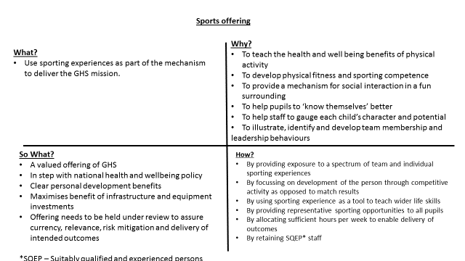

Policy written by **The Headmaster**

Policy managed and updated by **The Director of Sports**

|  |  |
| --- | --- |
| **Author** | **Governors & the Head Master** |
| Policy initiated |  |
| Review Frequency | Annual , as necessary |
| Latest reviews with changes made | March 2021 |
| Review due date | August 2022 |
| References |  |